APPLICATION FORM
ARTISTS
MEDITERRANEA 20 YOUNG ARTISTS BIENNALE
BORDERLESS!

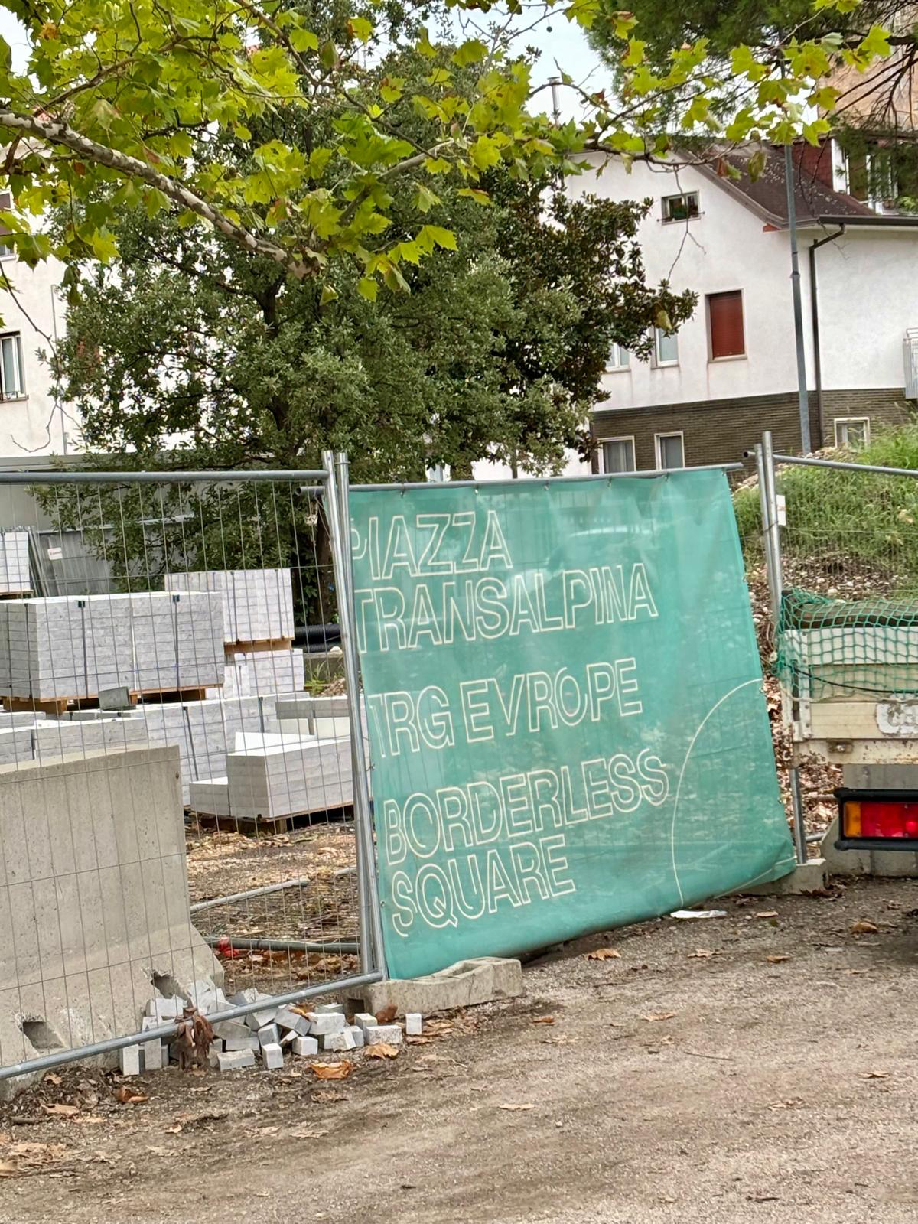

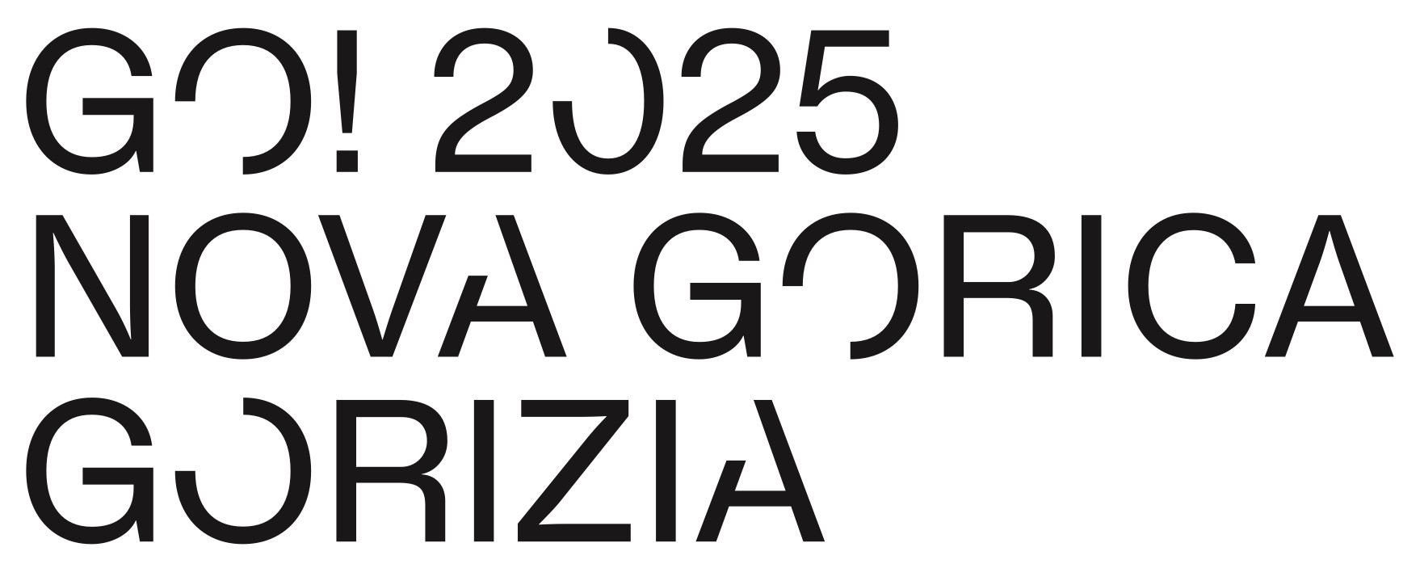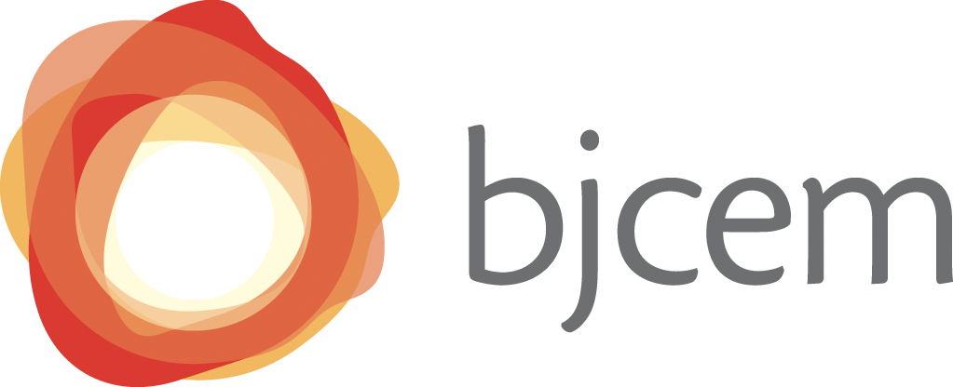

APPLICATION FORM
ARTISTS
MEDITERRANEA 20 YOUNG ARTISTS BIENNALE
BORDERLESS!

Deadline 31 October, 2024

Name
(As written in the passport)
Surname
(As written in the passport)

Date of birth

Citizenship

City of Residency*

Address

Country

Phone

Email

Website

*The round ticket will be purchased from and to this city

By submitting this application, you consent to the collection, processing, and storage of your personal data for the purpose of evaluating your eligibility for participation in the project. Your data will be treated confidentially and in accordance with the General Data Protection Regulation (GDPR).

